FOR IMMEDIATE RELEASE 30 October 2025

DACHAN BAY TERMINALS LAUNCHES FIRST SHIP-TO-SHIP LNG BUNKERING OPERATIONS

On 15 October, DaChan Bay Terminals marked a significant milestone with the launch of the first ship-to-ship liquefied natural gas (LNG) bunkering at the facilities in western Shenzhen. The terminals are operated by Modern Terminals Limited headquartered in Hong Kong.

At DaChan Bay Terminals, container vessel ZIM JASPER operated by ZIM Integrated Shipping Services Limited (ZIM) received 2,000 tonnes of LNG from bunker vessel XIN AO PU TUO HAO provided by Shenzhen PetroChina International LNG Bunkering Co., Ltd through a ship-to-ship transfer. ZIM JASPER is one of 28 modern LNG-fuelled vessels operated by ZIM on its global network. The arrangements can allow vessels to receive LNG fuel while container loading / unloading is being handled at berth and that can help reduce ship turnaround time and operational costs for shipping lines.

Horace Lo, Group Managing Director of Modern Terminals Limited said: “This inaugural LNG bunkering operations at DaChan Bay Terminals underpin the development of our terminal facilities as green ports. In June, we achieved Hong Kong’s first SIMOPS LNG bunkering at Modern Terminals Hong Kong and with the successful launch of the LNG bunkering services at DaChan Bay Terminals, it means all our customers can have LNG bunkering at any of our facilities.

“We will continue to work with all parties concerned to help ensure any green maritime fuel required by shipping lines will be available at our terminal facilities in both Hong Kong and DaChan Bay,” said Mr Lo.

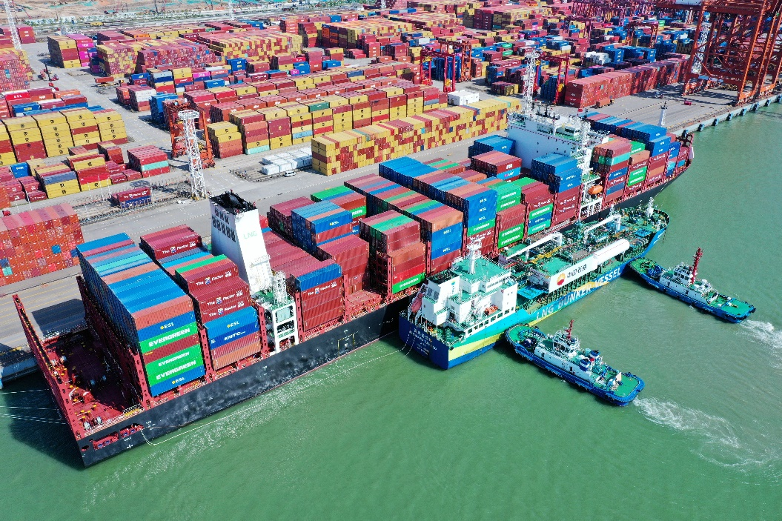
First ship-to-ship LNG bunkering at DaChan Bay Terminals.
…/2

- 2 -

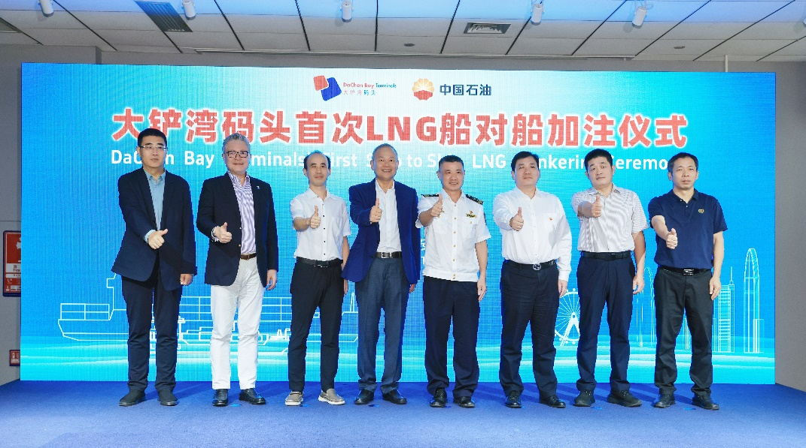

Guests celebrate the milestone for DaChan Bay Terminals at a ceremony.

-END-

Issued by Modern Terminals Limited. For further information, please contact:

Elin Wong
Head of Corporate Affairs
Modern Terminals Limited
Tel: (852) 2115 3640
Email: elin.wong@modernterminals.com

Media Enquiries: (852) 6376 6211; cad@modernterminals.com
Website: www.modernterminals.com

